User Manual

## <Accident Data User Interface>

Lambert Niyuhire, Cody Perkins, Mitchell Reid

Table of Contents

<Accident Data User Interface> 1

# Introduction

## Background

A system must be created to process the Victoria State Accident dataset, as it holds tons of information that would be beneficial to many organizations. The database that the system will provide is one that will allow for massive amount of data to be processed and filtered, so as to be used to conduct research upon it. The dataset contains the accident reports in Victoria state from the time period of 2015 to 2020, 5 years of data. The target audience of this dataset will include, but not be limited to, the Victorian police, insurance companies, road safety government comities and other organisations.

## System Overview

The Accident Data User Interface is a software application designed to facilitate the processing, filtering, and analysis of the Victoria State Accident dataset. This section provides an overview of the key components and features of the system.

# 2.0 How-to-Use

Before you can use the Accident Data User Interface, you need to ensure that you have the required software and dependencies installed on your system. Follow these steps for installation:

1. **Python Installation**: Make sure you have Python installed on your computer. You can download Python from the official website: [Python Official Website](https://www.python.org/downloads/).
2. **Required Libraries**: This application uses several Python libraries. You can install them using the following commands: pip install wxPython pandas matplotlib.
3. These libraries are essential for the proper functioning of the Accident Data User Interface.
4. Download dataset: Obtain the “Victoria state Accident dataset” that you want to work with. Ensure its available on your computer.

# 2.1 Running the Application

Now that you have the necessary dependencies and dataset, you can run the Accident Data User Interface:

1. Open a Terminal or Command Prompt: Launch a terminal or command prompt on your computer.
2. Navigate to the Application Directory: Use the cd command to navigate to the directory where the Accident Data User Interface code is located.
3. Run the Application: Execute the following command to run the application:  
   python mainApp.py. 
4. Application interface: The application interface will open, and you can start using it to work with the accident dataset.

# 2.2 Using the Application

Once the Accident Data User Interface is running, you can perform various tasks:

Loading Data: The application will automatically load the Victoria State Accident dataset (if its in the same directory as the application) upon start-up. If the data is loaded successfully, it will be displayed in the data grid.

Searching Data: Use the search bar at the top of the application to search for specific columns within the dataset. Enter a search term in the search bar and press "Enter" or click the "Search" button to filter the data. The data grid will display only the columns containing the search term.

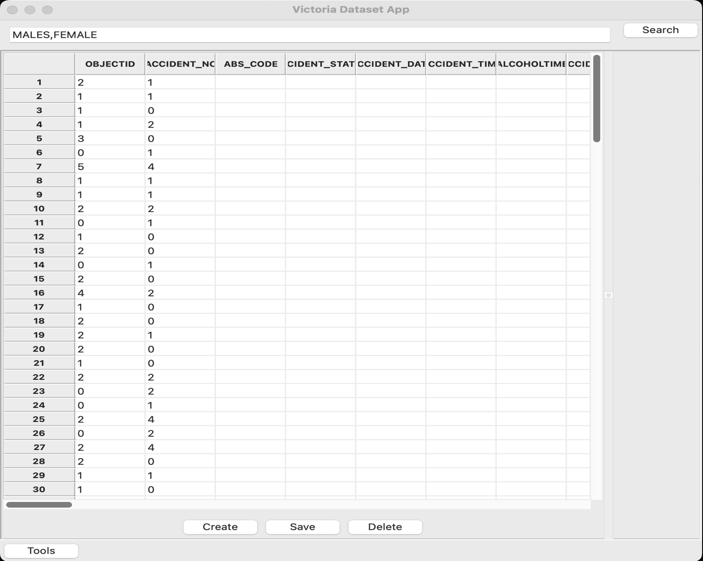

Creating Bar Charts: Click the "Create" button to create bar charts based on selected columns. Enter the names of the columns you want to use to create a bar chart (comma-separated). Provide labels for the x-axis, y-axis, and the chart title. A labels for the x-axis, y-axis, and the chart title. A bar chart will be generated and displayed in the right panel.

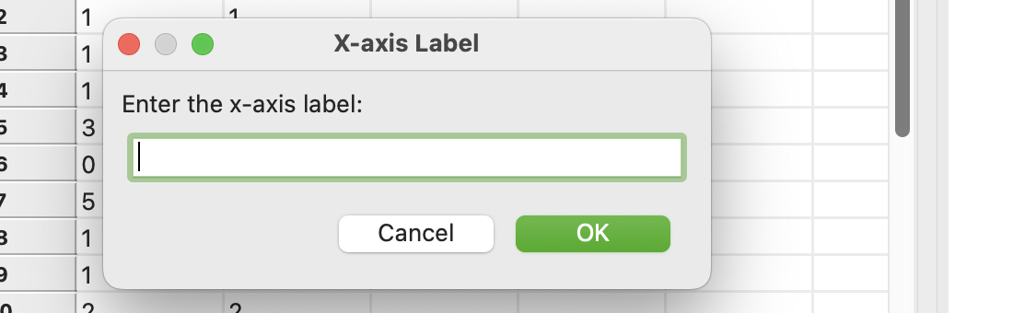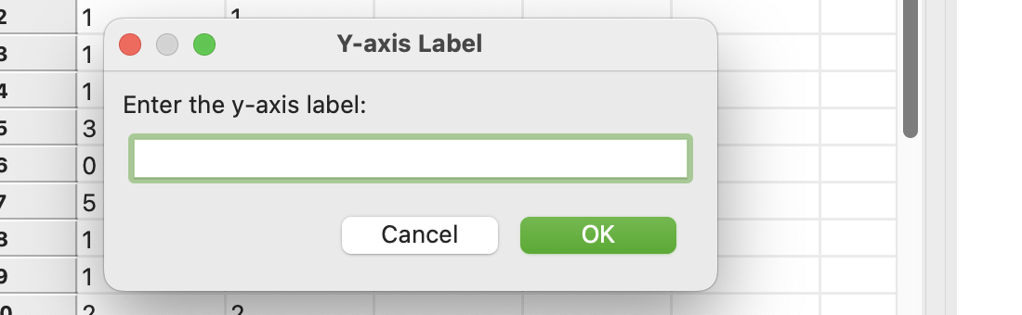

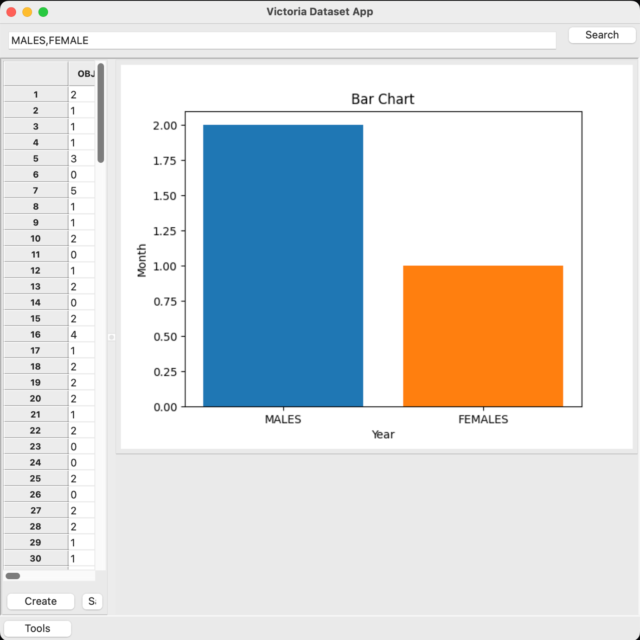

Saving and Deleting Data: The "Save" and "Delete" buttons are placeholders for custom functionality. You can implement custom logic to save or delete data as needed.

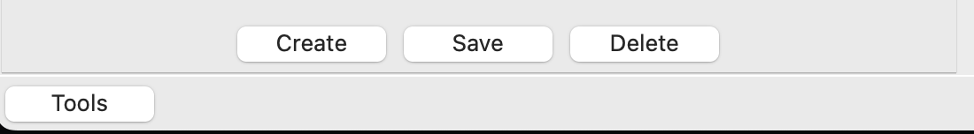

# 2.3 Navigating the Application

Tool Dialog: Click the “Tool” buttons to open the “Tools Dialog.” From the dialog, you can access other screens and features, such as loading data and viewing a calendar. 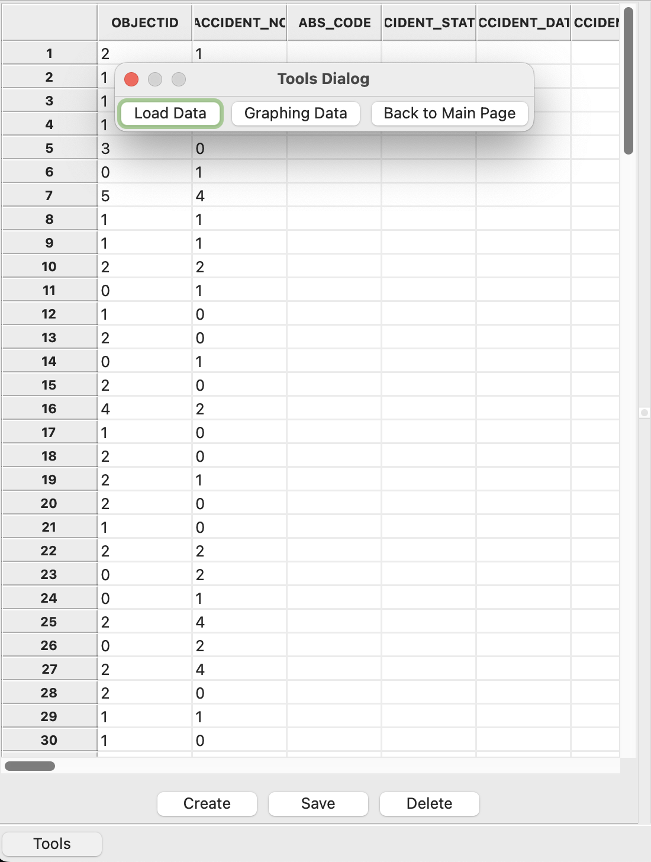

Calendar and Dataset Screen: The "Calendar and Dataset Screen" allows you to view a calendar control and the dataset simultaneously. It provides an overview of data related to specific dates.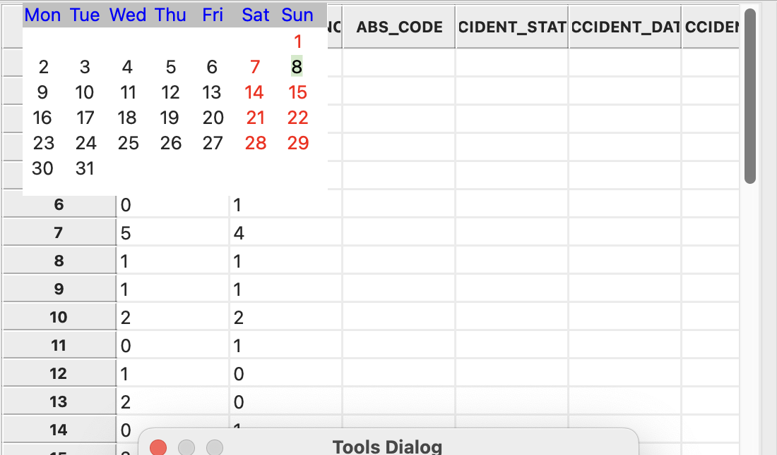

# 2.4 Advanced Features

Preferences: The "Preferences" menu item in the "Options" menu allows you to customize application settings. You can configure settings like theme, colors, and data source.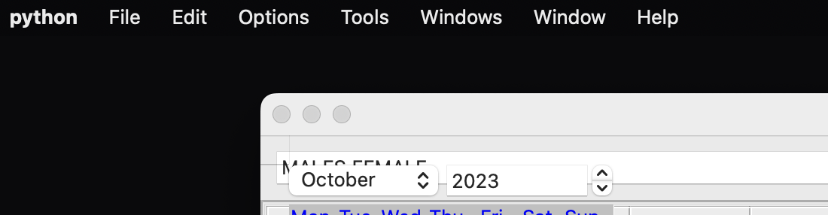

Additional Tools and Windows: The "Tools" menu provides access to additional tools and windows. These tools may include data analysis, reporting, and other advanced features.



# 2.5 Troubleshooting

If you encounter issues, check the following:

* Ensure you have installed the required libraries.
* Verify that the "Victoria State Accident dataset" is in the same directory as the application.
* Check for error messages in the terminal or console.

Error Handling:

* The application includes error handling for common scenarios.
* Error messages will be displayed as pop-up dialogs with relevant information.

# 3.0 About

Application Information: The "About" menu item in the "Help" menu provides information about the application, including the version number and developer details.

# 3.0 Credits

This application was created by Lambert Niyuhire, Cody Perkins, and Mitchell Reid.

This user manual provides guidance on installing, running, and using the Accident Data User Interface. It also covers advanced features, troubleshooting, and information about the application.

# 